Personal Media History
This essay will cover my growth and journey through my life as it pertains to the media I have been exposed to, both as a child and as an adult. My name is Jessica Siller, I am a 38-year-old woman who chose to return to school during the 2020 Covid pandemic.
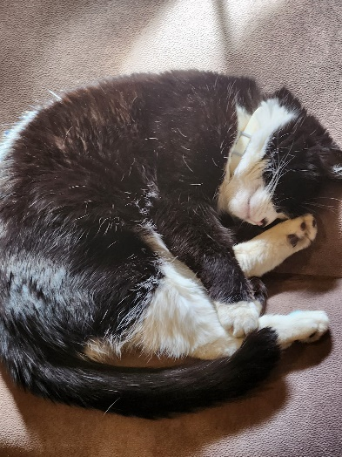
I currently reside in rural Hanover County Virginia, with my husband and our menagerie of pets. I spend my time enjoying gardening, writing, creating stained glasswork, listening to music, playing video games, and begrudgingly RC car racing from time to time.
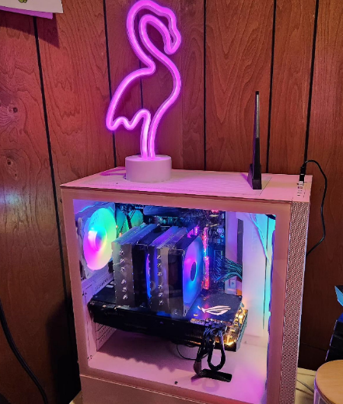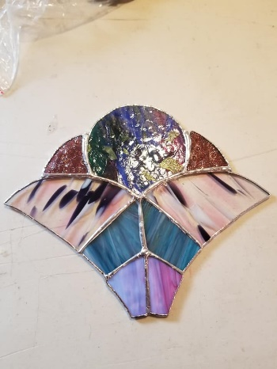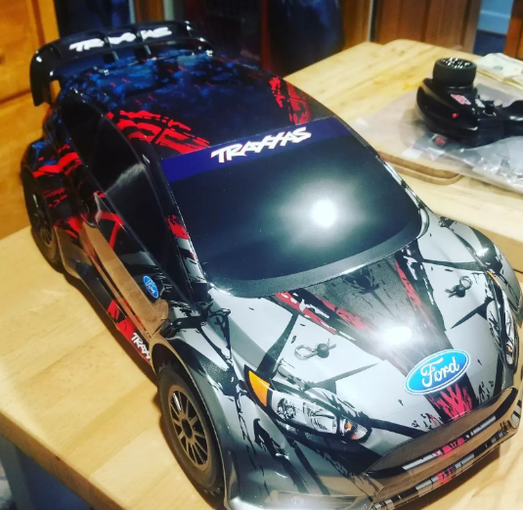
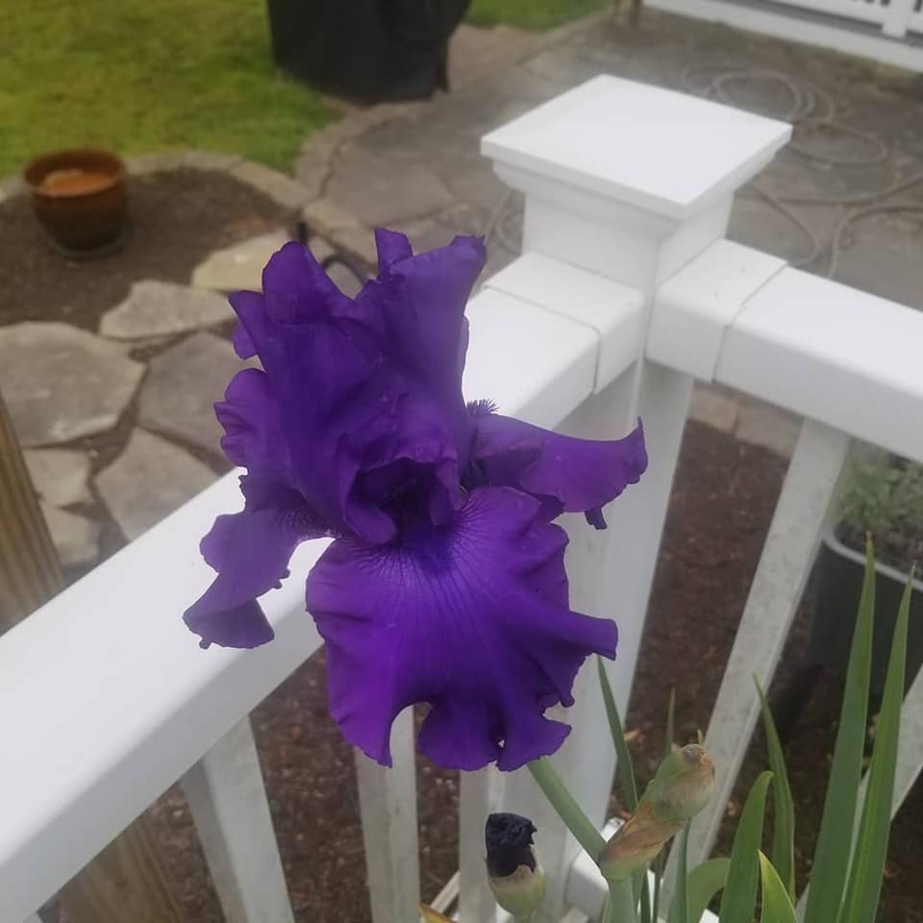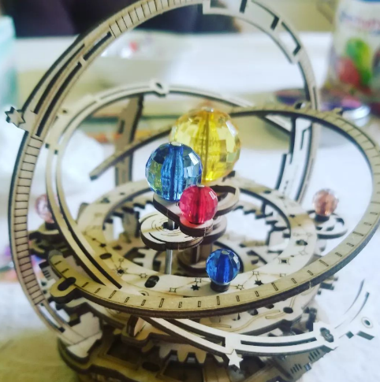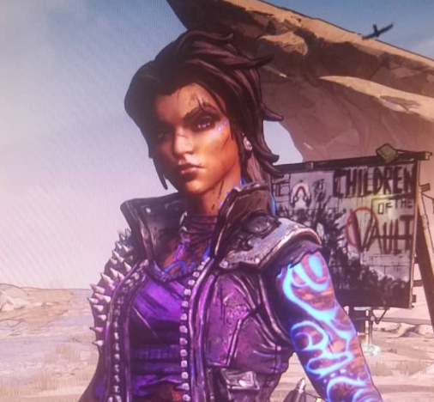
When I first returned to higher education, I was focused on potentially obtaining a Risk Management degree, as I already had experience in that field, but after obtaining my Business Administration Associations from Virginia Peninsula Community College, and to be honest, after barely making it through my precalculus and calculus coursework, I decided to change my focus to Professional Communications. Having a background in an array of professional positions, experiencing endless job searches, and a traumatic lay off earlier this year, I have come to learn that I posses many skills, skills that would not normally be registered as being compatible, but used in communications can raise people’s empathy and understanding. Perhaps unsurprisingly, the choice to return to school in the fall of 2021, came indirectly through the spiraling media coverage of business recovery after the pandemic. I have been able to return to work full time, in a position that was created specifically for my skill set, and am forever grateful for the networking I have been able to achieve through my work ethics.
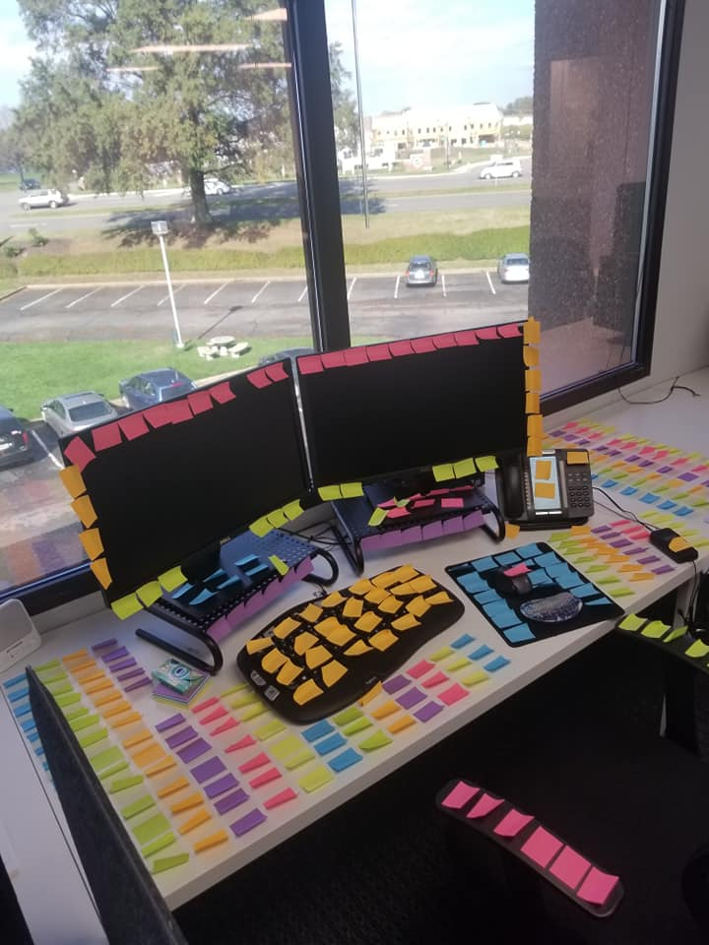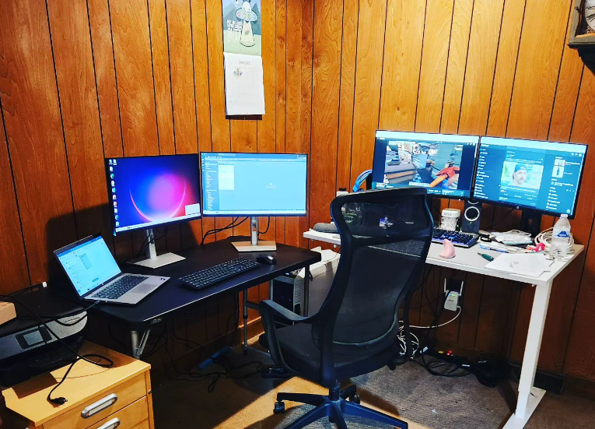
As a harsh aside from many of my classmates, I grew up in a time when computers were still being developed, the home personal computer still quite a luxury for many adults. But other forms of media helped shape and create who I am today. Perhaps, unsurprisingly, I spent a great deal of my youth watching television, especially staying home from school to watch Bob Barker on the Price is Right with a ginger ale, saltine crackers and some chicken soup. Saturday morning cartoons would advise my brother and I which toys we needed to harp on our parents incessantly until they were in our possession. Two examples of such preposterous, yet provided requests, were for Popples and a Micromachine Super Van city playset. Media also played a significant role in my school life, we would watch scientific or education videos on a VHS player, some even on LaserDisc, we would also attend typing classes in a computer lab weekly. Growing up listening to the radio, I still remember advertisement jingles from local Richmond stores, so much that I could sing them back to you now as an adult. The first home computer came into my brother and I’s lives when we were in elementary school, it was an old Macintosh, and we would play games like The Dig or Kings Quest both of which came on multitudes of 3.5 floppy disks.
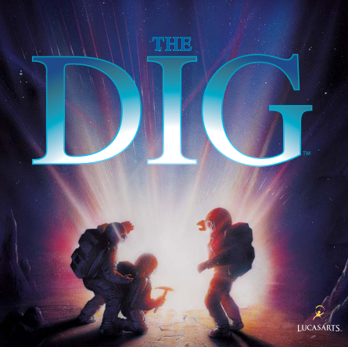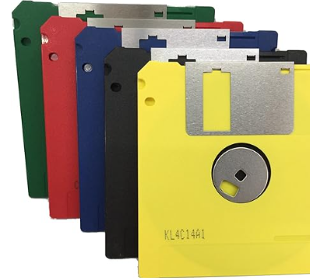
Our second home computer would arrive when my brother and I were in late middle school to early high school, and only made an appearance due to our father working on his Masters degree. This computer, we were not often allowed to touch. I received my first cellphone at the age of 17, a little Siemens A56, which was only capable of calling my parents, as texting cost money at the time. I would then go on to get my first personal use computer, a Dell, in 2003 as I went to university at UNLV. This would be around the time I ventured into my own personal social media account, on the social media site Myspace.
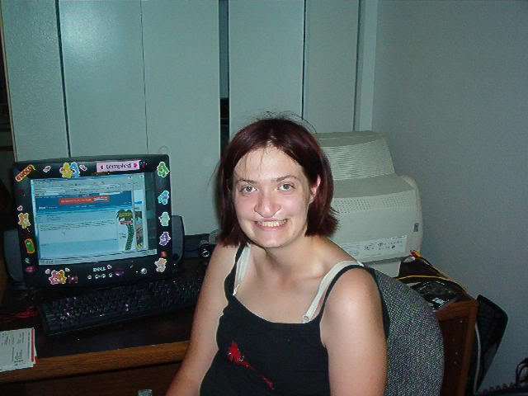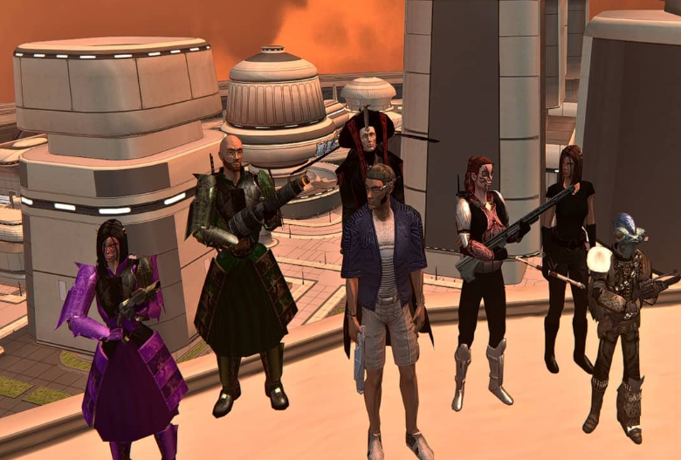
As a young adult, I would continue to grow my presence on social media sites, and while I was reckless at times like any number of young people are, I tended not to overshare. As I have aged, and grown more mature, I notice that I spend much less time with social media, even going so far as to advocating for young people to be wary regarding what they are posting online. While social media is not my preferred form of media, I do have a very private Facebook, Instagram, TikTok and LinkedIn presence, thus locating media for this assignment as I hardly share new things going on.
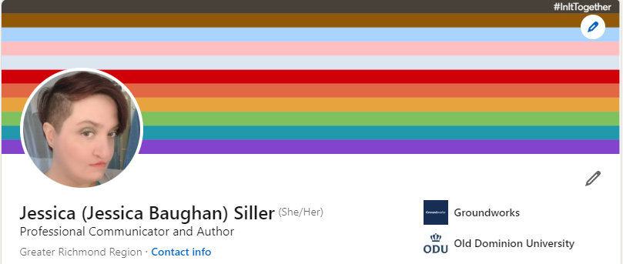
I am also heavily influenced by media in other avenues, and have used forms of media to influence those around me, such as news, podcasts and written media. As stated before, I have written several papers and articles regarding the need for companies to have social media policies and for everyone to be extremely mindful of what current and potential employers can see on people’s public personas. I also spend my personal time writing fiction dark fantasy and horror short stories and novels, which I hope to have published someday. Further as a person who is employed full time and working from home, I am able to get obtain my fix of media consumption to break up the monotony of Excel spreadsheets, by listening to Youtube videos, podcasts, the news, music and sometimes a movie I have seen a million times just to have a background buzz going. The last form of media, which I believe no person is able to escape at this point is that of advertisement. My personal email inbox is only advertisements for a sale going on at a place I have previously purchased from before. Advertising is so invasive and prevalent that even my ODU student email receives advertisement alerts from the university bookstore. My Facebook feed is mostly advertisements that are directly being linked to whatever random thing I have recently searched for online, the algorithms are all knowing and all encompassing.
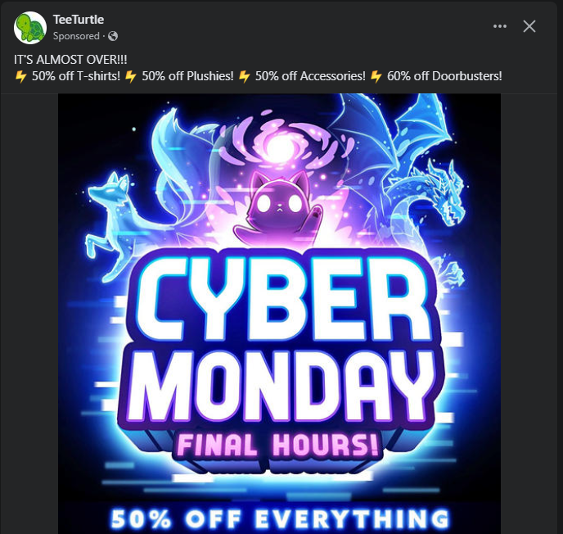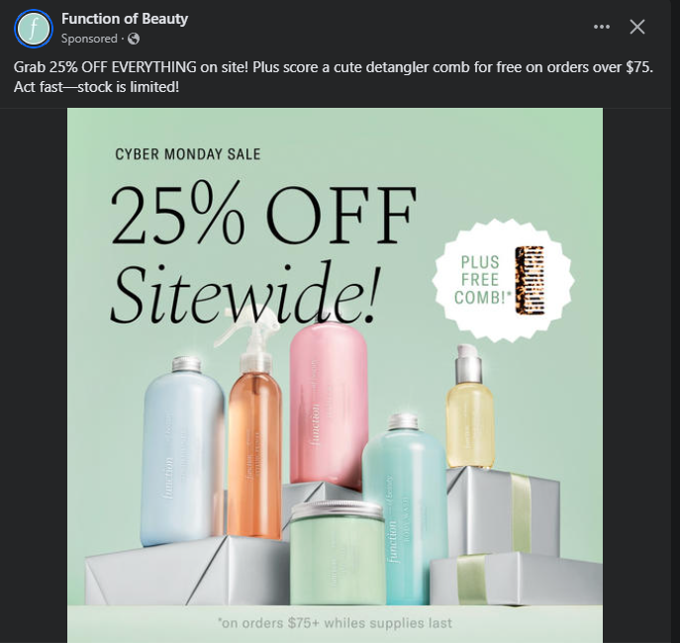
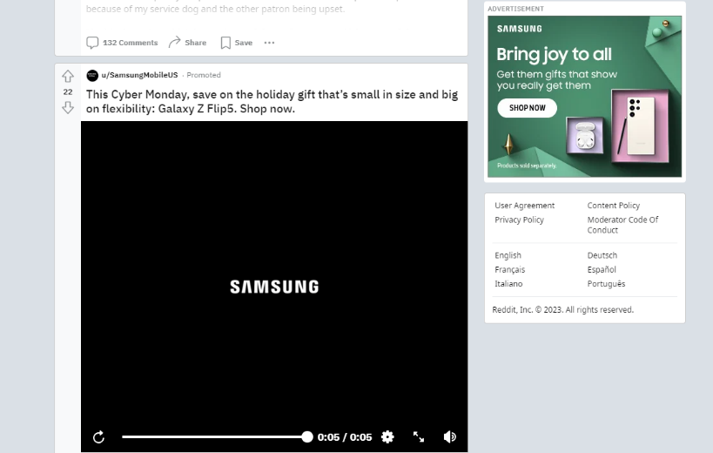
While media is not the direct focus, I plan on approaching with my degree program, it is an inevitable and important part of mine and so many other people’s everyday lives.

